**Sample**

**EMERGENCY ACTION PLAN**

Organization Name

Address

City, State

Updated: _______________

**TABLE OF CONTENTS**

**Workplace Emergencies Introductions…………………………………..3**

**General Information……………………………………………...................3**

**Tenant Emergency Coordinator Roles & Responsibilities……...........4**

Emergency Coordinator**…………………………………………...…..4**

Floor Captain**……………………………………………………….......5**

Aides for Members with Disabilities**…………………………………..5**

**General Instructions for Reporting Emergencies…………………..…...6**

Medical Emergencies**……………………………………………..…....7**

Fires**………………………………………………………………..….....8**

Active Shooter & Workplace Violence**……………………………......9**

Bomb Threats**…………………………………………………………..10**

Severe Weather & Natural Disasters**……………………………...…11**

Extended Power Loss**……………………………………………..…..12**

Persons with Disabilities**…………………………..……………….....13**

**Attachments…………………………………………………………………..14**

Zone Listing**…………………………………………………………....14**

Bomb Threat Card**…………………………………………………….15**

SAMPLEPosition Matrix**……….………………………………….….16**

SAMPLE Personnel Roster**…………………………………………..17**

**WORKPLACE EMERGENCIES**

**Introduction**

This Emergency Action Plan (EAP) establishes guidelines for all reasonably foreseeable workplace emergencies. Because each emergency situation involves unique circumstances, the guidelines provide general guidance only. Thoughtful actions based on situation assessment are always required when responding to an emergency. It is also important to note that emergency guidelines do not necessarily represent sequential series of steps.

|  |
| --- |
| **Special Note:** *Safety and health are the overriding priorities in all emergency situations. Think before you act and… if you see something, say something!* |

Each site is expected to develop their own Emergency Action Plans because they best understand the nature of their work, potential workplace hazards, the layout of their worksites, and special needs specific to their location.

Develop your EAP to address preparedness measures and emergency response. The EAP is a way for your site to plan for potential emergencies ranging from small accidents to regional disasters. Advanced planning and a Department EAP will help reduce risk and loss of life. It is important that all employees read and understand their worksite emergency action plan.

**General Information (Refer to “EAP Position and Personnel Roster”)**

Emergencies can be identified as Medical, Fire, Severe Weather, Bomb Threats, Chemical Spills, Terrorist Attacks, Criminal Acts, Extended Power Loss, etc. Personnel should be able to identify these emergencies and immediately report them to Security. Security will contact Surveillance who will call 911 and if necessary, the Emergency Coordinator [position title] responsible for the site.

Alerting Personnel

The following applies to workplace emergencies requiring evacuation such as fires:

* Activate the fire alarm.
* Contact Security to information them of the situation and location.
* Personnel will first, calmly evacuate all guest and then staff, using the closest designated escape routes. (see appendix A – Floor layout with emergency exits)
* Personnel will look in rooms as they leave and notify other personnel to exit; do not delay your evacuation for this purpose if the threat is near you.
* Personnel will assemble and remain in the evacuation assembly area identified in Appendix A.Leaving the group or failing to report to the evacuation assembly area can cause unnecessary effort locating personnel believed to be missing and place others in harm’s way.
* Immediately notify Security of any missing or unaccounted for personnel.
* Stay alert and listen for instructions.
* Await guidance to disperse, return to the building or take additional measures.
* In the event of a medical or other emergency that does NOT require evacuation, contact Security.

**Floor layouts with identified emergency exits – (see Appendix A)**

**Assembly Area – (See Appendix B)**

**ROLES & RESPONSIBILITIES**

**Refer to “EAP Position and Personnel Roster”**

Authority: Emergency Coordinator (Name position i.e., Security Manager or on-duty Security Supervisor), Floor Captain (Security Officers), and Aides (other employees/managers) are responsible to evacuate personnel and assist guest and persons with disabilities to the assembly area. Upon arrival of Emergency Services (Fire Chief, Incident Commander) will assume command.

1. Emergency Coordinator (EC)

*Non-Emergency Responsibilities:*

* Ensure the dissemination, implementation and updating of the EAP is conducted anytime there is a physical change to the property, staff changes, or any other changes directly connected with this plan.
* Review and update EAP annually.
* Ensure personnel are assigned to all EAP positions and trained in their job requirements.
* Conduct exercises regularly to optimize personnel emergency response, at a minimum, one time per year.
* Conduct and document a post action review following any drill and emergency event and provide a copy to the risk management office.
* Assure all life safety devices are inspected and tested, and remain in working order, such as, fire drop doors, fire extinguishers, emergency lighting, emergency warning indicators (strobes, lights, audible warnings), emergency exits are unobstructed and accessible at all times.
* The EAP will be maintained in accordance with Life Safety Practices and include:
* Emergency escape procedures and emergency escape route assignments.
* Procedures to be followed by personnel who remain behind to operate/conduct critical operational requirements before they evacuate.
* Procedures to account for all personnel following evacuation.

*Duties/Responsibility during an Emergency:*

* Ensure Security supervisors and officers initiate and complete accountability and/or evacuation.
* Coordinate the orderly evacuation of guest and personnel when needed.
* Obtain accountability for our guest and personnel following the incident and/or evacuation.
* Provide emergency response personnel with necessary facility information.
* Notify management & emergency responders of unaccounted for personnel.

1. Floor Captain (FC) (Position Title)

*Non-Emergency Responsibilities****:***

* Understand the building's emergency procedures and be prepared to assume his/her responsibilities promptly and calmly during an emergency.
* Know the location of all emergency and safety equipment and devices and how to operate them.

*Duties/Responsibilities during an Emergency:*

* Put on a safety vest, take your radio and cellphone, and ensure accountability for all personnel on duty.
* During an evacuation, direct people outside to the assembly areas and exit.
* Upon arrival at the assembly area, confirm all personnel are present or are otherwise accounted for including on shift but off property.
* Immediately notify Emergency Coordinator of unaccounted or missing personnel.

1. Aide for Persons with Disabilities (Other Managers/employees)

*Non-Emergency Responsibilities:*

* Understand the building's emergency exit locations and emergency procedures, be prepared to assume his/her responsibilities promptly and calmly in an emergency.

*Duties/Responsibilities during an Emergency:*

* Take your cellphone.
* Locate mobility impaired person(s) and assist them in getting to the designated mobility impaired location or by exiting the building.

1. All other Personnel

* Know and understand all information in the EAP.
* Read updates to the EAP when provided.
* Know the names and contact info for personnel serving as EC/FC/APD, where to find the closest first-aid kits, AED’s, fire extinguisher, evacuation routes and procedures, and assembly area locations.
* Make your way to safety and/or designated meeting location
* If you cannot get to the emergency meeting location immediately contact your supervisor, Security personnel, etc. by cellphone and state your location and if you need emergency assistance.

1. Staff Training Requirements

* All staff at all levels are required to receive emergency procedures training and annual refresher training
* Staff is required to be trained and annually trained in fire extinguisher use
* All staff is to be trained in evacuation and shelter in place procedures
* Security staff and management staff are required to be trained and maintain certifications in first-aid, CPR and AED’s.
* Department procedure training is required for any department required in post event operations

**GENERAL INSTRUCTIONS FOR REPORTING**



***911***

**EMERGENCIES**

Summons emergency assistance by contacting (????) or calling **911.**

Be prepared to provide the following information:

1. Your name and location.
2. Location of the emergency, including facility area, location, room #.
3. Type of emergency, such as:
   * Medical
   * Fire
   * Nature event such as tornado, severe rain, lightning storms, earthquake, etc.
   * Hazardous Material
   * Criminal Act
   * Bomb Threat
4. Other potentially important Information:
   * Number and condition of victims.
   * Location and extent of situation, hazard, fire, etc.
   * Involvement of Hazardous Materials (as available, give product name and/or describe any markings, labels, or placards).
5. What is needed

**DO NOT HANG UP FIRST.** Let emergency personnel hang up first.

After the call, station someone to direct Security or emergency response personnel to the scene of the emergency.

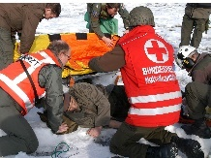**MEDICAL EMERGENCIES**

Survey the scene; evaluate personal safety issues.

Request assistance (CALL FOR HELP)

**Call Security**

Provide information such as:

* Number and location of victim(s)
* Nature of injury or illness
* Hazards involved
* Nearest entrance (emergency access point)

Alert trained employees to respond to the victim’s location and bring a first aid kit and/or Automated External Defibrillator (AED), or any other medical devices needed.

**Location of First Aid Kits and Automated External Defibrillator(s)**

|  |  |
| --- | --- |
| **First Aid Kit** |  |
| **Automated External Defibrillator** |  |

**Procedures**

* Only trained responders should provide first aid assistance.
* Do not move the victim unless the victim’s location is unsafe.
* Keeping the victim calm
* Keep a crowd control parameter
* Take “universal precautions” to prevent contact with body fluids and exposure to bloodborne pathogens.
* Meet the ambulance at the nearest entrance or emergency access point; direct them to victim(s).

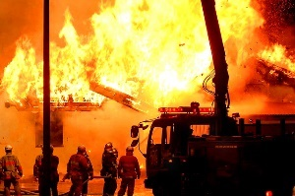**FIRES**

**Fire Emergency Plan**

If a fire is reported and cannot be contained, pull the closest fire alarm, (if available and not already activated) to warn occupants to evacuate. Call Security to alert them to the location. Provide the following information:

* Nature of fire
* Fire location (building and floor location)
* Name of person reporting fire

*\*\*\*Emergency Coordinator and Floor Captains to direct evacuation of personnel as necessary\*\*\**

**Evacuation Procedures**

* Evacuate building along evacuation routes to primary outside assembly areas.
* Redirect building occupants to exits away from the fire.
* Evacuation team to account for all employees and visitors at the assembly area.

**ACTIVE SHOOTER AND WORKPLACE VIOLENCE**

**Profile of an Active Shooter**

An Active Shooter is an individual actively engaged in killing or attempting to kill people in a confined and populated area, typically through the use of firearms.

**How to respond when an Active Shooter is in your vicinity**

|  |  |  |
| --- | --- | --- |
| 1. Evacuate | 1. Hide Out | 1. Take Action |
| * Have an escape route and plan in mind * Leave your belongings behind * Keep your hands visible | * Hide in an area out of the active shooters view * Block entry to your hiding place and lock doors. | * As a last resort and only when your life is in imminent danger. * Attempt to incapacitate the active shooter * Act with physical aggression and throw items at the active shooter |
| **\*\*\*\*\*\*\*\*\*\*\*\*\*\*\*\*\*\*\*\*\*\*CALL 911 WHEN IT IS SAFE TO DO SO\*\*\*\*\*\*\*\*\*\*\*\*\*\*\*\*\*\*\*\*\*\*\*\*\*\*\*\*\*\*\*** | | |

**How to respond when Law Enforcement arrives on the scene**

|  |  |
| --- | --- |
| How you should react when Law Enforcement Arrives |  |

|  |  |
| --- | --- |
| * Remain calm and follow officers’ instructions * Immediately raise hands and spread fingers keep hands empty * Avoid making quick movements towards officers such as attempting to hold on to them for safety | * Avoid pointing, screaming, and/or yelling * Do not stop to ask officers for help or directions when evacuating. Just proceed in the direction from which the officers entered the premises. |

|  |
| --- |
| Information you should provide to Law Enforcement |

|  |  |
| --- | --- |
| * Location of active shooter * Number of shooters, if more than one * Physical description of shooter(s) | * Number and type of weapon(s) * Number of potential victims at the location |

**ROBBERY PROCEDURES** [](https://www.google.com/url?sa=i&rct=j&q=&esrc=s&source=images&cd=&ved=2ahUKEwj76aqrr6HlAhXOop4KHQtWA1EQjRx6BAgBEAQ&url=https://www.gettyimages.com/detail/photo/masked-robber-with-gun-royalty-free-image/178074206&psig=AOvVaw2fLdXOWjZCCGGJpIAFCb4y&ust=1571335536027718)

**Profile of a Robbery**

Armed robbery is one of the most serious and potentially dangerous crimes committed in the United States today. Personal safety is always the most important consideration when planning how to react to an armed robbery.

**Procedures During a Robbery**

Proper employee training of procedures to follow during a robbery is vital to surviving the confrontation. Conduct documented training and discussion periods so that every employee knows their part and has an opportunity to ask questions. The overriding consideration in dealing with a robbery is to reduce the possibility of injury.

* **Do not resist the robber**. The money is not worth risking a life. Take no action that would jeopardize the safety of personnel or customers.
* **Do not use or encourage the use of weapons against the robber**. Introducing another weapon into the situation increases the chances of someone becoming injured or worse during the robbery.
* **Try to inform the robber of any surprises**. If someone is expected back soon or if you must reach or move in any way, tell the robber what to expect so they will not be startled.
* **Follow the robber’s commands, but do not volunteer to help**. The longer the robbery takes, the more nervous the robber can become and more apt to become violent.
* **If the robber demands a specific amount of money**, only give them the amount they demand.
* **Try to include “bait money” along with other cash**. “Bait money” could be a bundle of recorded currency kept in the draw or a concealed dye pack.
* **Try to keep customers and employees calm** during the robbery.
* **If the robber displays a firearm or claims to have one**, consider it loaded and that they would use it.
* **Activate the holdup alarm**, if possible, and only if it can be safely done without being obvious to the robber.
* **Try to alert other employees** of the situation by using prearranged signals.
* **Be observant**. Plan to be a good witness. Try to notice as much as possible about the robber.
* Make mental notes of the following:
  + The number of robbers.
  + The robber’s physical characteristics, including: race, sex, age, height, weight, facial characteristics (head shape, color of hair, color of eyes, shape of eyes, nose and mouth, etc.) speech patterns (i.e., accents), scars, marks and/or deformities, right or left-handed.
  + The robber’s clothing description
  + Any names used by the robbers
  + Any peculiarities exhibited by the robber (i.e., smelled of alcohol, appeared to be “high” on drugs, etc.).
  + Description of any weapons used. Try to notice barrel length, barrel color, color of grips, whether a pistol is automatic or a revolver.
* **If the robber uses a written note**, try to place behind the counter or register out of sight to retain it as evidence, try to limit handling it.
* **After the robber has the money**, offer to have employees and customers lie down instead of waiting for the robber to decide want to do, such as knocking you down or tying you up.

**Procedures After the Robbery**

* Establish which personnel will take certain actions if a robbery occurs. Decide ahead of time which employee will lock the doors, who will call 911, who will care for the injured, who will look for the getaway car, who will protect the evidence, etc. Don’t assume these jobs will be done automatically.
* Do not chase or follow the robber outside. The robber may shoot at any pursuers or the police may shoot at you, too, thinking you are a robber.
* Secure the doors so the robbers cannot reenter the store. Stop business operations and place a sign on the door advising customers that the business is “Temporarily closed.” Do not let anyone in, except Security, management and law enforcement.
* Call 911 immediately. Tell them if anyone is injured so they may dispatch medical personnel if necessary. Give dispatch the time of the robber’s departure, their description and direction and method of travel. Stay on the telephone until they tell you it is okay to hang up. The speed of reporting to 911 is critical.
* Care for any injured people.
* If it can be safely accomplished as the robbers leave, try to note their method of escape along with the direction of travel. If a vehicle is used, try to find out the make, color, type, license number and the state of registration.
* Try to preserve any potential evidence. Protect the scene of the crime and do not touch anything the robber may have touched including a note. Keep all people out of the area.
* Immediately each employee and any guest should write down the description of the robber. Do not “compare notes” with others.
* Ask witnesses to remain until the police arrive. If they insist on leaving, try to obtain their names and telephone numbers, or get their license plate number.
* Contact store manager. Emergency contact numbers should be accessible and the notification policy clearly established.
* Do not discuss the crime with outsiders until police give permission to do so. Refer all questions to the police.
* Do not tell or estimate how much money was lost to the robber unless absolutely necessary. Find out and record anything else that may have been stolen. If an exact amount of cash taken during the robbery should be released to the media and they report a large loss, other robbers could be attracted to the business or others in the chain.
* Assist the investigating officers in every way possible. Cooperate with the police by being available for interviews, do not be reluctant to identify suspects and giving evidence in court when notified to do so.

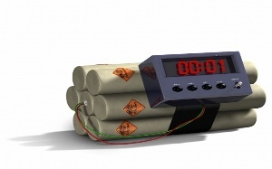**BOMB THREATS**

**Phone Bomb Threat**

* Stay calm – do not alarm others.
* Notify your supervisor who will report the threat to **911**. If supervisor is not present, call 911 directly using a land line.
* Fill out the *Bomb Threat Card* (**See Appendix C**) to assist responding agency.
* Decision to evacuate the building will be made by the on duty Supervisor.
* Always treat a bomb threat as it were a real threat
* Take the Bomb Threat Card with you if the building is evacuated.

**Written Bomb Threat**

* Remain calm and leave the message where it is found.
* Do not handle the document any more than necessary to preserve fingerprints and other evidence.
* Do not alarm others.
* Notify your supervisor who will report the threat to **911**. If supervisor is not present, you call 911.
* Do not give information to anyone except supervisor, and 911.

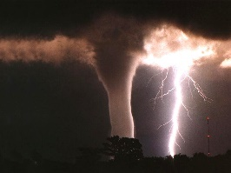**SEVERE WEATHER**

**AND NATURAL DISASTERS**

**Earthquakes:**

* Stay calm and await instructions from [Emergency Coordinator or Other Designated Official].
* Evacuate if instructed by [Emergency Coordinator or Other Designated Official].
* Keep away from overhead fixtures, windows, filing cabinets, and electrical power sources.
* Assist people with disabilities in finding a safe place.

**Floods:**

* If indoors:
* Be ready to evacuate, as directed by [Emergency Coordinator or Other Designated Official].
* Follow the recommended primary or secondary evacuation routes.
* If outdoors:
* Climb to high ground and stay there.
* Avoid walking or driving through flood water.
* If your car stalls, abandon it immediately, and climb to a higher ground.

**Tornado:**

* When a warning is issued by radio, sirens or other means, seek shelter inside. The following are recommended locations for shelter:
* Small interior rooms on the lowest floor and without windows,
* Hallways on the lowest floor away from doors and windows, and
* Rooms constructed with reinforced concrete, brick, or block with no windows.
* When a warning is issued by sirens, or radio or other means, seek shelter inside.
* Stay away from outside walls and windows.
* Use arms to protect head and neck.
* Remain sheltered until the tornado threat is announced to be over.
* Grounds immediately go to the closest building, if and when it is safe to do so.
* Employees are to discourage anyone attempting to go outside from doing so, but don’t place yourself in harm’s way.

**Severe Lightening Storm:**

* Seek shelter inside immediately
* Stay away from outside doors and windows
* Grounds immediately report to the main building
* Employees are to discourage anyone attempting to go outside from doing so, don’t place yourself in harm’s way in the process though.

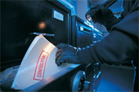**EXTENDED POWER LOSS**

While the facility has an emergency backup generator, in the extreme case it does not operate, and in the event of extended power loss to the facility certain precautionary measures should be taken:

* Unnecessary electrical equipment and appliances should be turned off in the event that power restoration would surge causing damage to electronics and effecting sensitive equipment.
* Facilities with freezing temperatures should turn off and drain the following lines in the event of a long-term power loss.
  + Fire sprinkler system
  + Standpipes
  + Potable water lines
  + Toilets
* Equipment that contain fluids that may freeze due to long term exposure to freezing temperatures should be moved to heated areas, drained of liquids, or provided with auxiliary heat sources.

Upon Restoration of heat and power:

* Electronic equipment should be brought up to ambient temperatures before energizing to prevent condensation from forming on circuitry.
* Fire and potable water piping should be checked for leaks from freeze damage after the heat has been restored to the facility and water turned back on.

**PERSONS WITH DISABILITIES **

**Employee and Supervisor Responsibilities**

If there are guest or employees with a disability, there are critical steps to take to help ensure their safety during an emergency. For employees first, inform a supervisor if they may require assistance in the event of an evacuation. Second, work with the supervisor to develop a plan to ensure safe evacuation in the event of an emergency. An employee with disabilities should review the procedures to be followed in an emergency situation affecting the facility and familiarize themselves with the evacuation routes and assembly areas.

If you are a supervisor/manager, you are responsible for reviewing the facility’s EAP with all employees under your supervision, including those with disabilities, to ensure each employee clearly understands procedures that must be followed during an emergency event. Be proactive in developing emergency plans to ensure safe evacuation to meet the needs of employees with a disability. You should include any employees with disabilities in the decision-making process when selecting special equipment and developing evacuation procedures in collaboration with Security.

**Procedures**

Options for disability evacuation include:

* Shelter in Place—Take immediate shelter at the designated location.
* Evacuation Chair or Other Assistive Device—An evacuation chair or escape chair is a lightweight wheelchair used to evacuate a physically disabled person from an area of danger, such as a burning building. The chair is designed to allow an attendant to transfer the person down stairs more safely than could be done with a normal wheelchair. Such chairs may be folded to a small size and stowed in much the same manner as other firefighting equipment such as fire hoses and fire extinguishers.
* Two-person Carry—This is a way to carry a person to safety with the assistance of a partner. The two assistants link arms to form a backrest and grip wrists to from a seat.

Please remember, when making decisions regarding the best way to evacuate individuals with disabilities from the building, work closely with the local emergency response personnel or safety specialists.

**ATTACHMENT 1 Zone Listing**

**(INSERT FACILITY FLOOR PLAN COLOR-CODED BY ZONES IF APPLICABLE)**

**(INSERT FACILITY FLOOR PLAN ESCAPE ROUTES, PULL STATION AND FIRE EXTINGUIGHER LOCATIONS)**

**(INSERT PROPERTY MAP IDENTIFYING ALL SAFE MEETING LOCATIONS)**

**(INSERT BUILDING MAP IDENTIFYING ALL SHELTER-IN-PLACE LOCATIONS)**

**ATTACHMENT C Bomb Threat Card**

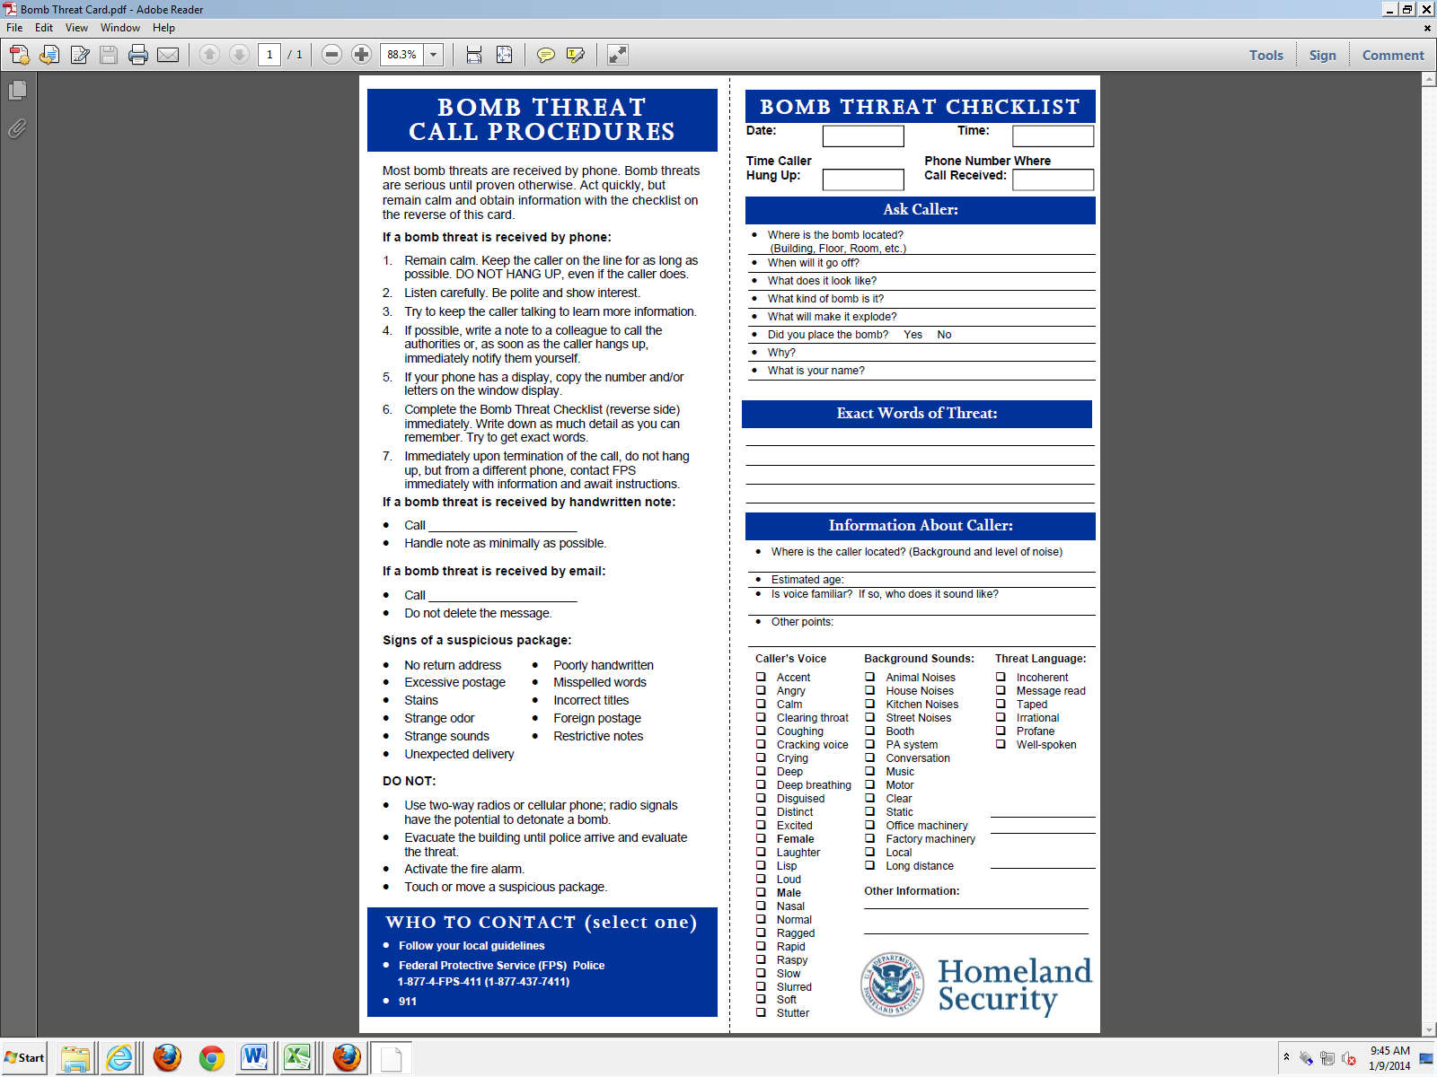

**ATTACHMENT SAMPLE Position Matrix**

|  |  |  |  |  |
| --- | --- | --- | --- | --- |
| **Position** | **Name** | **Office Room #** | **Mobile Phone** | **Office Phone** |
| Emergency Coordinator |  |  |  |  |
| Alternate #1 Emergency Coordinator |  |  |  |  |
| Alternate #2  Emergency Coordinator |  |  |  |  |
| Zone A  Floor Captain |  |  |  |  |
| Alternate  Zone A  Floor Captain |  |  |  |  |
| Zone B  Floor Captain |  |  |  |  |
| Alternate  Zone B  Floor Captain |  |  |  |  |
| Zone C  Floor Captain |  |  |  |  |
| Alternate  Zone C  Floor Captain |  |  |  |  |
| Aide for Persons with Disabilities |  |  |  |  |
| Aide for Persons with Disabilities |  |  |  |  |
| Alternate  Aide for Persons with Disabilities |  |  |  |  |
| Alternate  Aide for Persons with Disabilities |  |  |  |  |

**ATTACHMENT 2 SAMPLE Personnel Roster**

**List Updated as of XX Jan 20XX**

**FLOOR CAPTAIN**

|  |  |  |  |
| --- | --- | --- | --- |
| **Name** | **Office Room #** | **Mobile Phone** | **Office Phone** |
| Primary |  |  |  |
| Alternate |  |  |  |

**PERSONNEL**

|  |  |  |  |
| --- | --- | --- | --- |
| **Name** | **Office Room #** | **Mobile Phone** | **Office Phone** |
|  |  |  |  |
|  |  |  |  |
|  |  |  |  |
|  |  |  |  |
|  |  |  |  |
|  |  |  |  |
|  |  |  |  |
|  |  |  |  |
|  |  |  |  |
|  |  |  |  |
|  |  |  |  |
|  |  |  |  |
|  |  |  |  |
|  |  |  |  |
|  |  |  |  |
|  |  |  |  |
|  |  |  |  |
|  |  |  |  |
|  |  |  |  |
|  |  |  |  |
|  |  |  |  |
|  |  |  |  |
|  |  |  |  |
|  |  |  |  |
|  |  |  |  |
|  |  |  |  |